Assignment 6.5

Problem Statement

Titanic Data Analysis

Write a mapreduce code to find out number of males and females survived in the titanic tragedy and save the output in sequence file output format.

**Driver class**

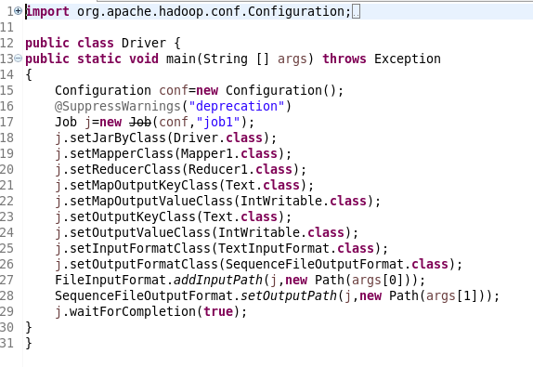

**Mapper**

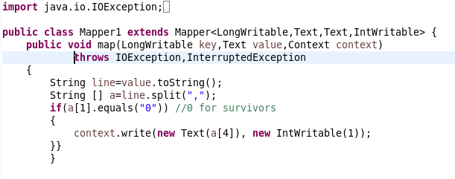

**Reducer**

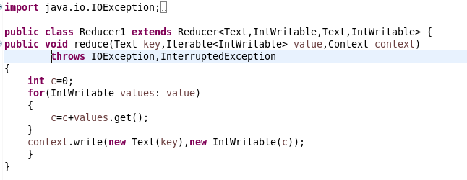

**Jar command**



**Output**

